**ASSIGNMENT -1**

1. In your home directory, create sets of empty practice files

* Create 6 files with names of the form songsX.mp3.

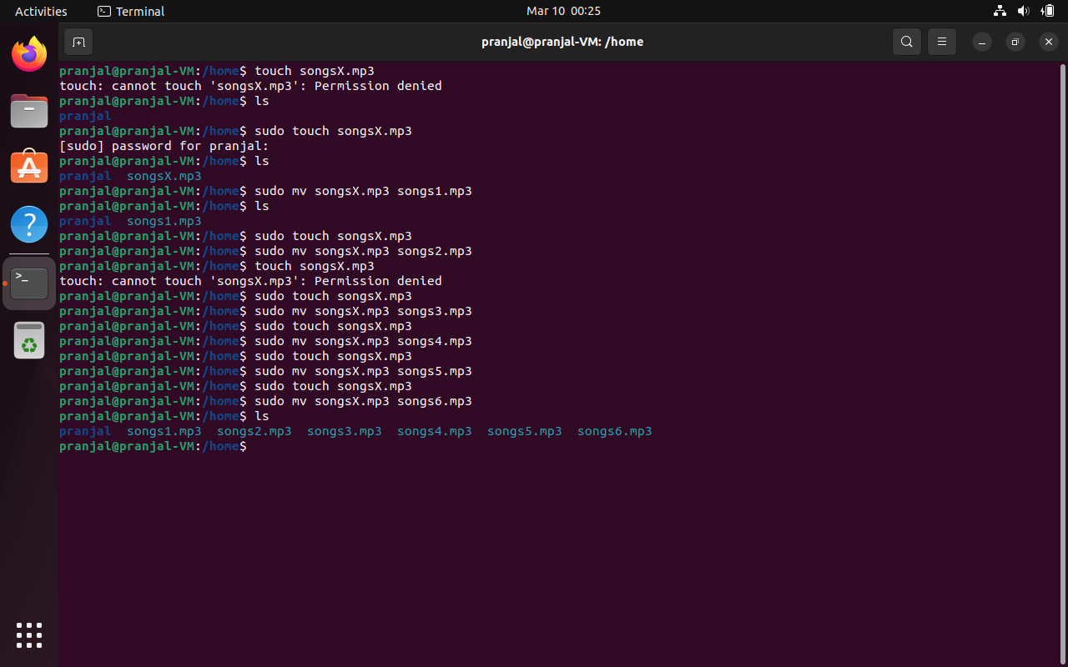

* Create 6 files with names of the form snapX.jpg.

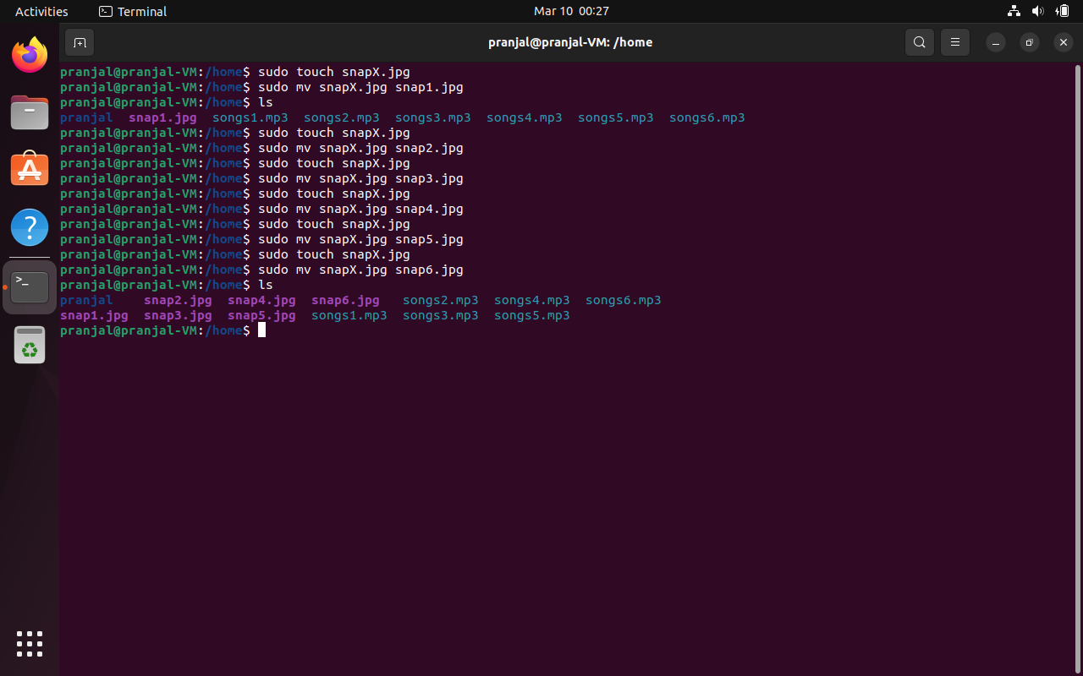

* Create 6 files with names of the form filmX.avi.

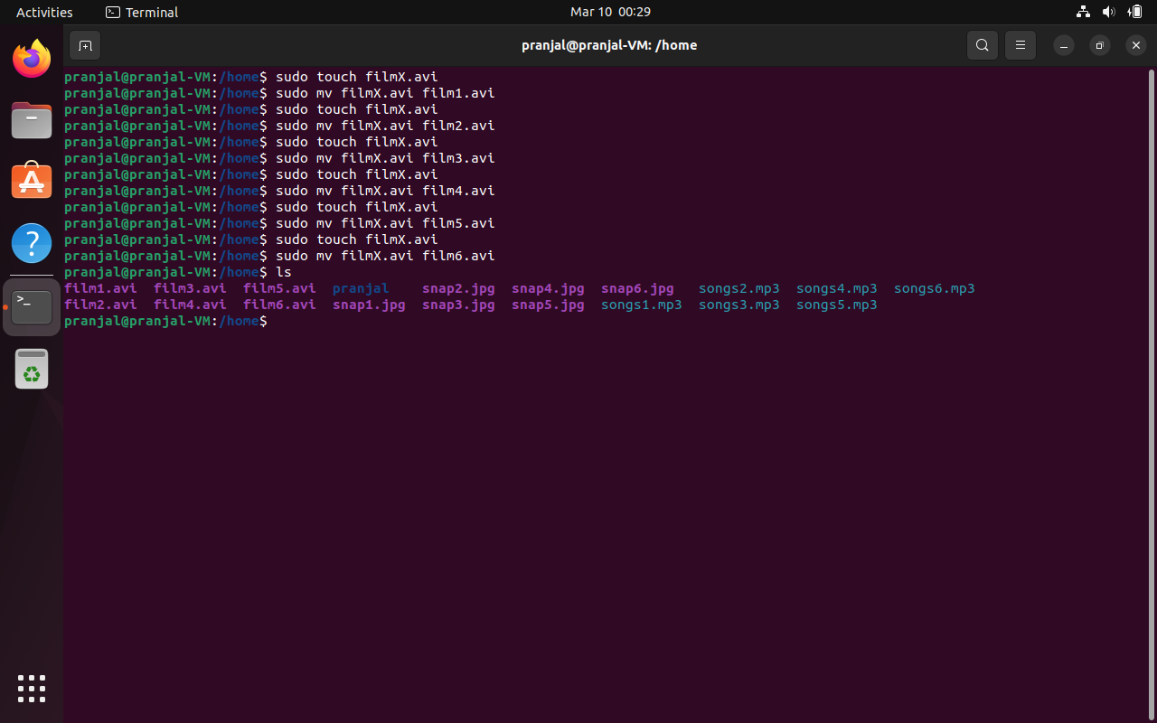

2. From your home directory,

* Move songs file into your Music subdirectory.

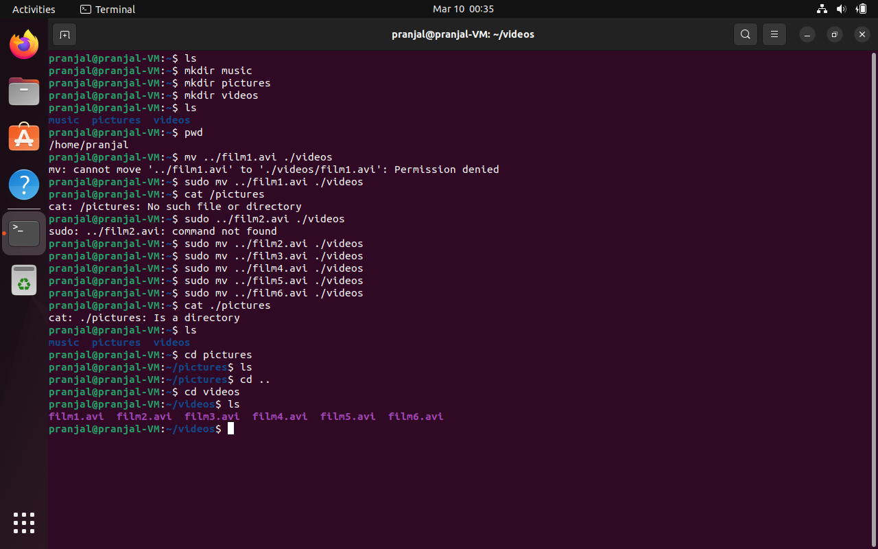

* Move snap file into your Pictures subdirectory.

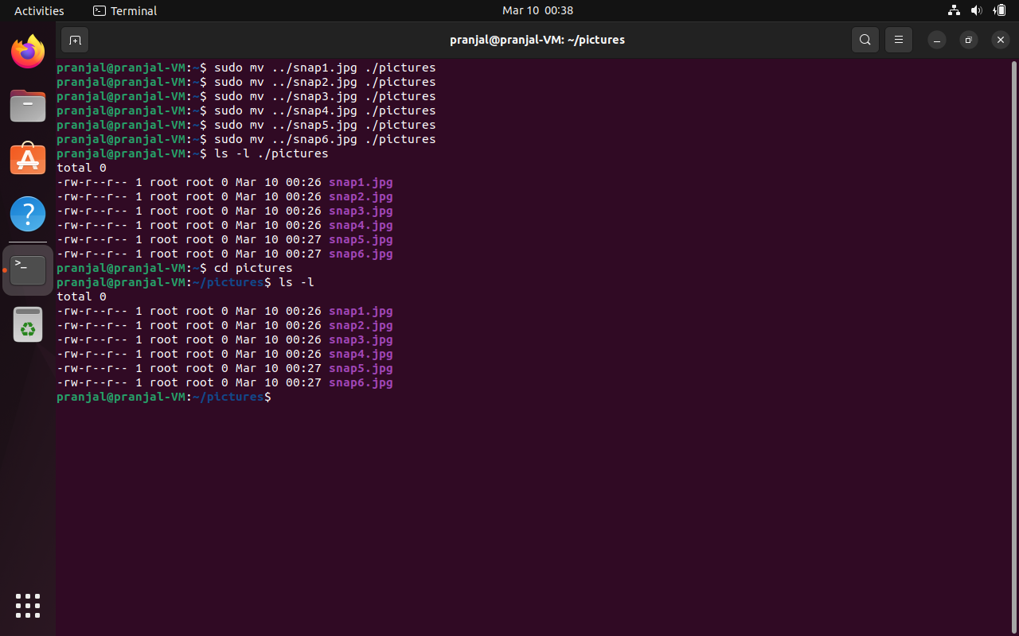

* Move your movie files into Videos subdirectory

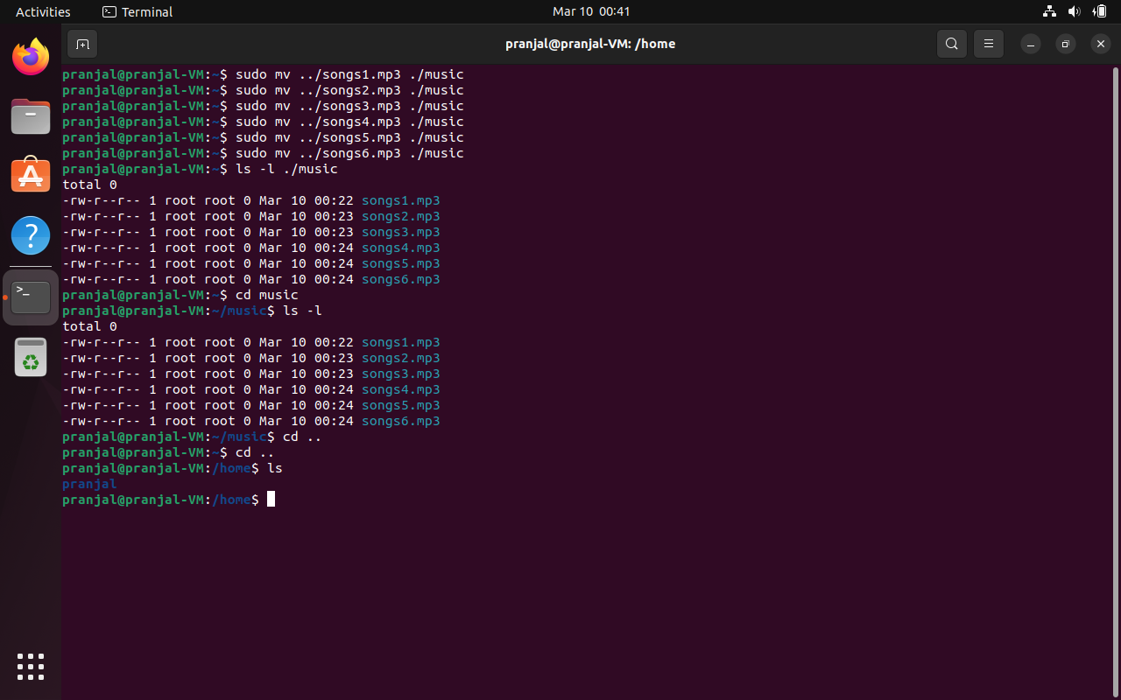

3. Create 3 subdirectories for organizing your files named friends,family,work

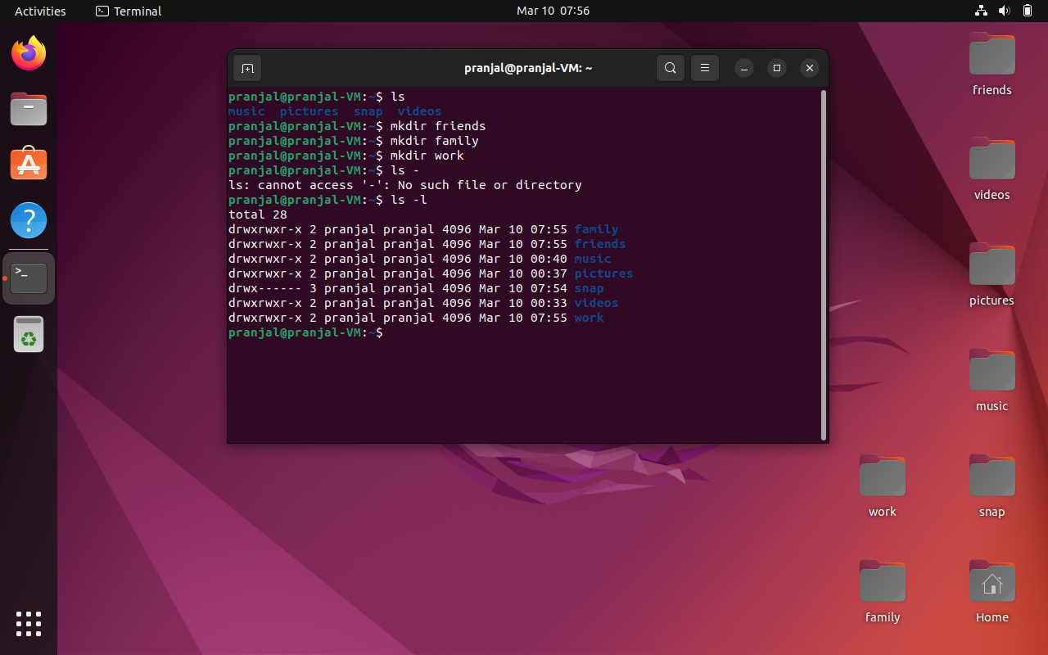

4. Copy files (all types ) containing numbers 1 and 2 to the friends folder.

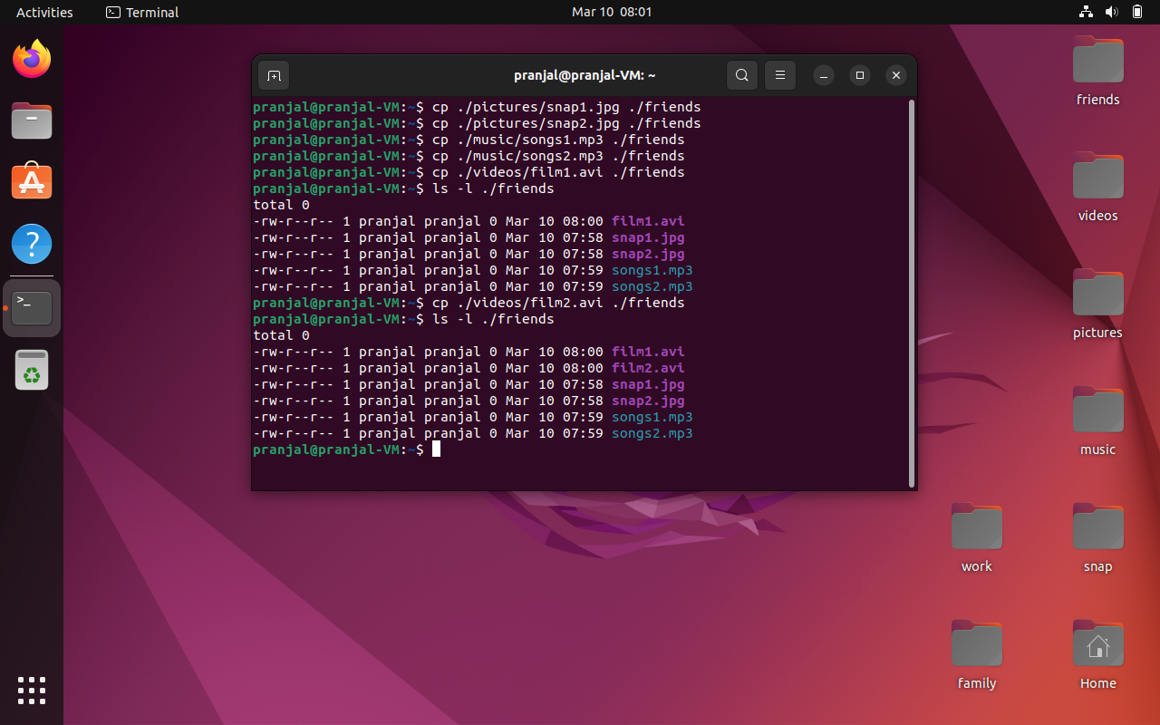

Copy files (all types) containing numbers 3 and 4 to the family folder.

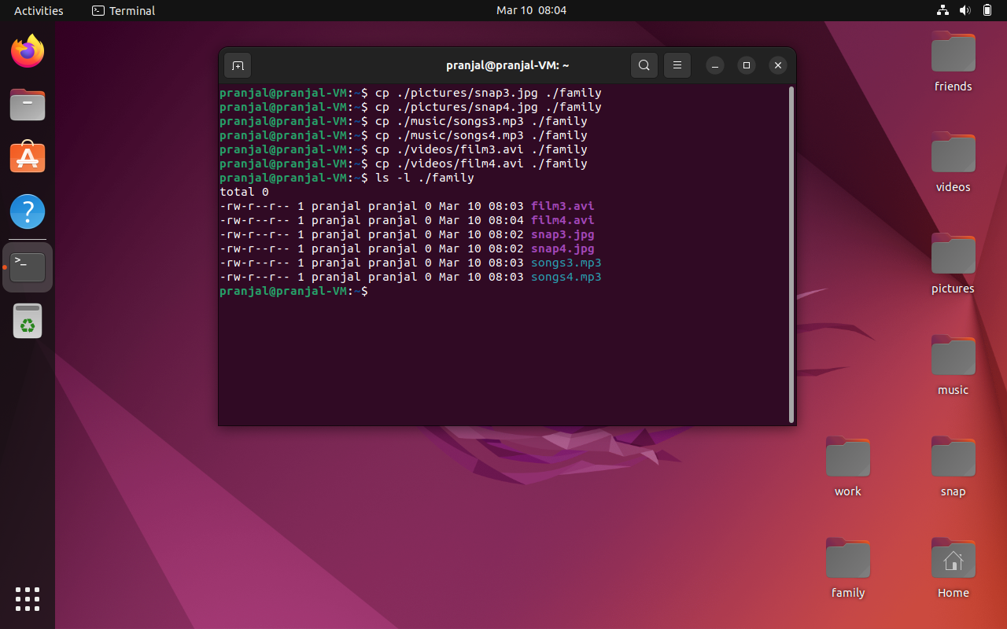

Copy files (all types) containing numbers 5 and 6 to the work folder.

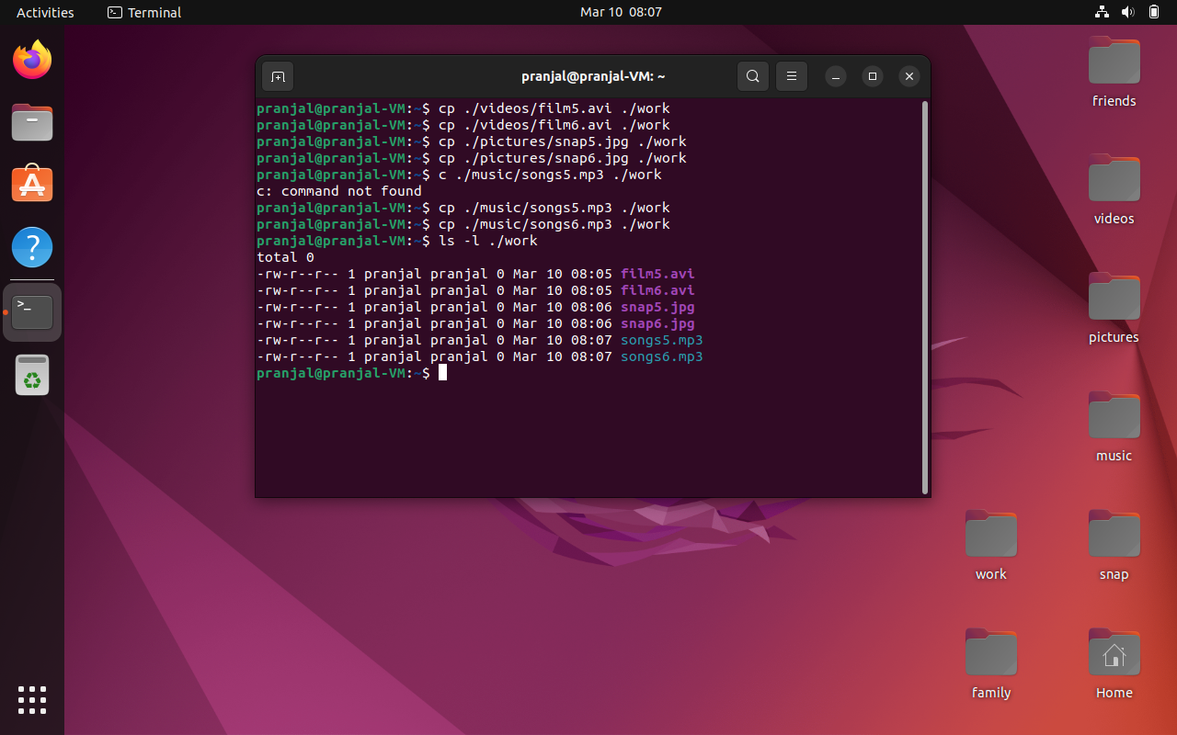

6. Delete all files in family subdirectory.

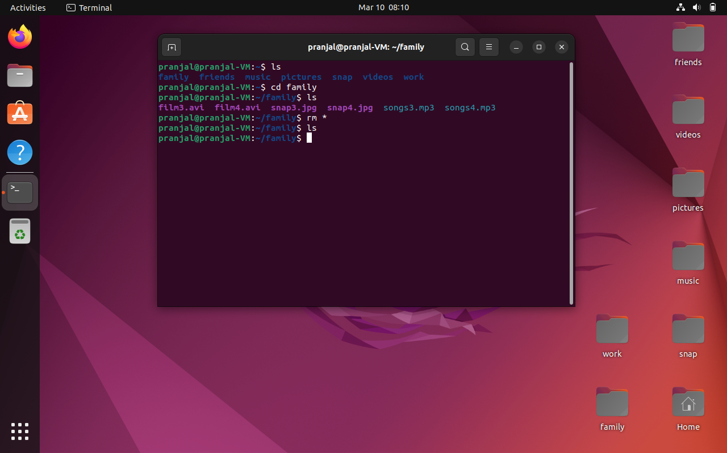

7. Delete friends subdirectory

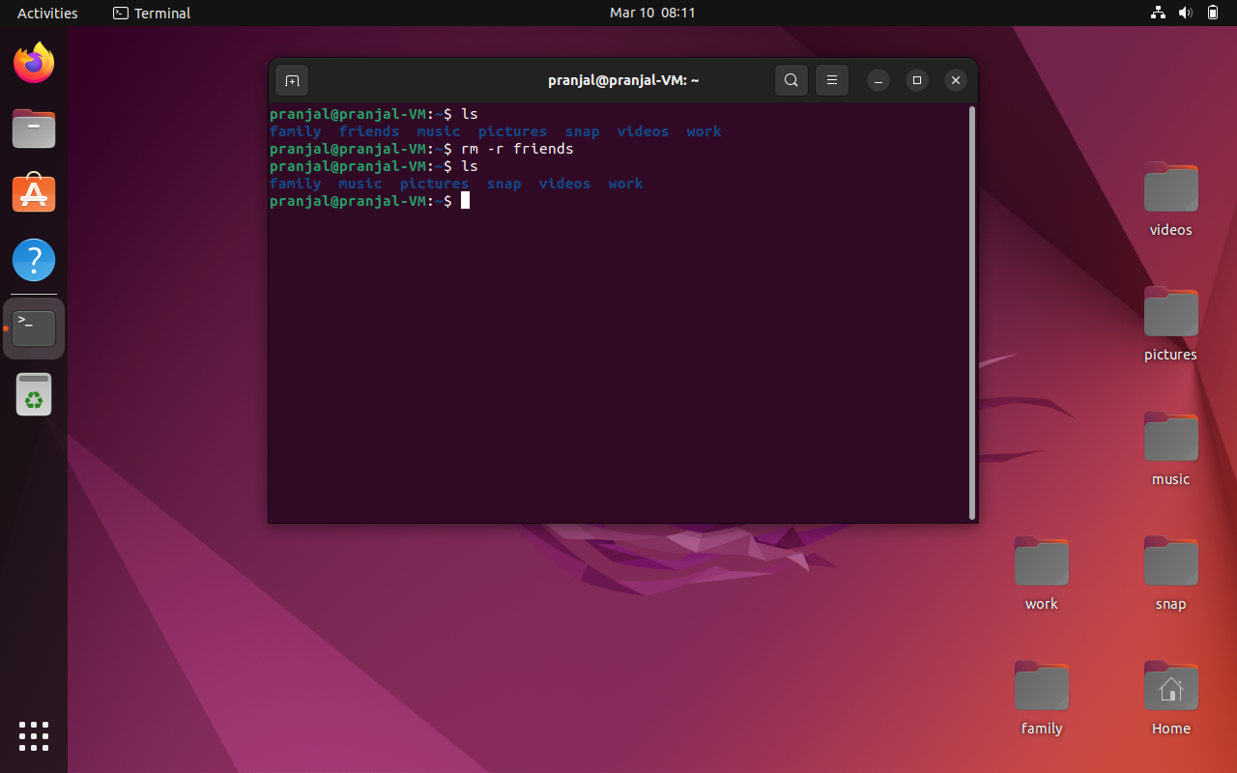

8. Create user tom , bob , sam , prince

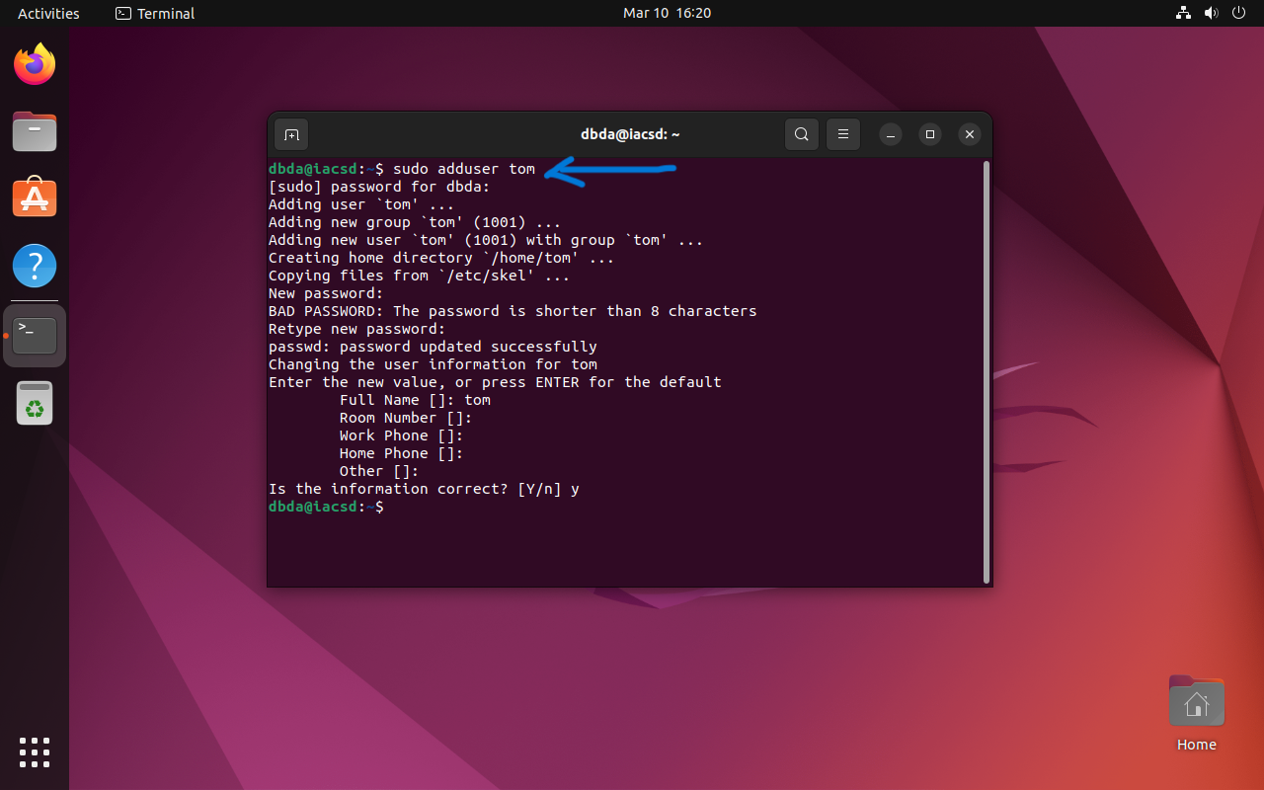

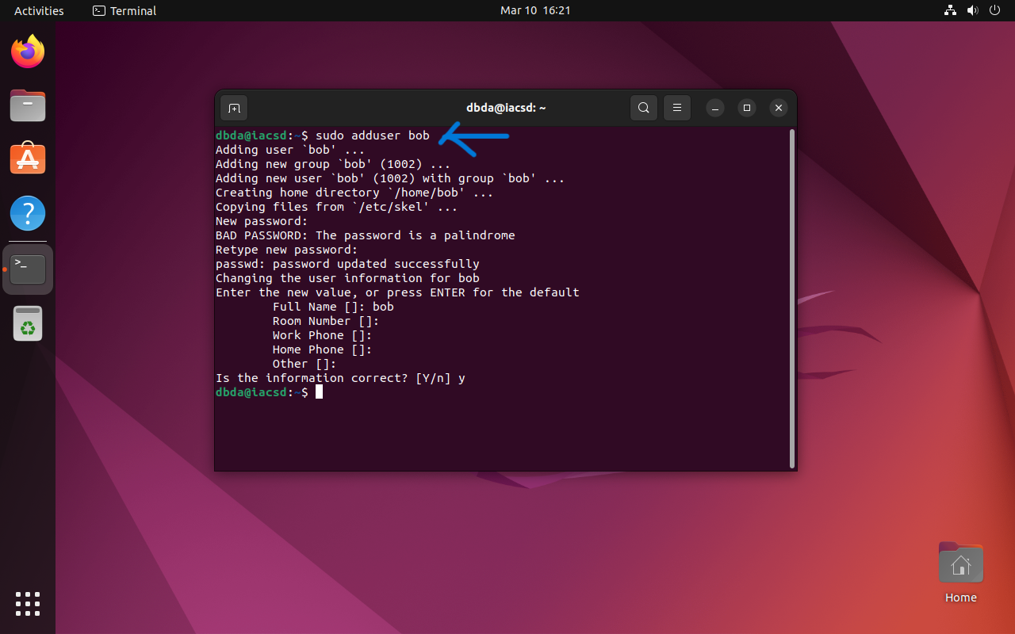

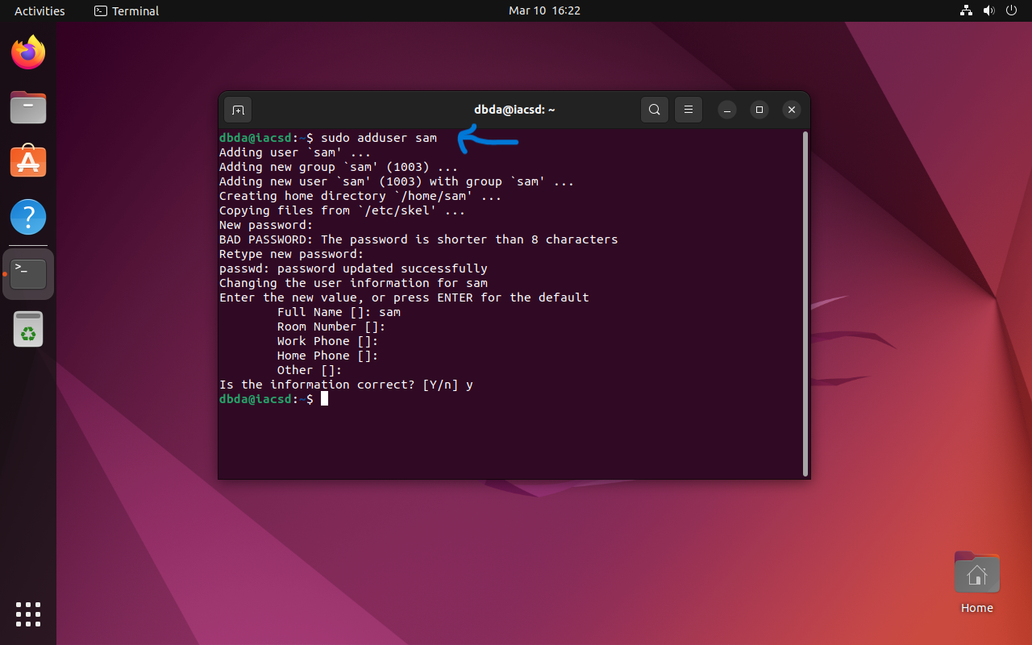

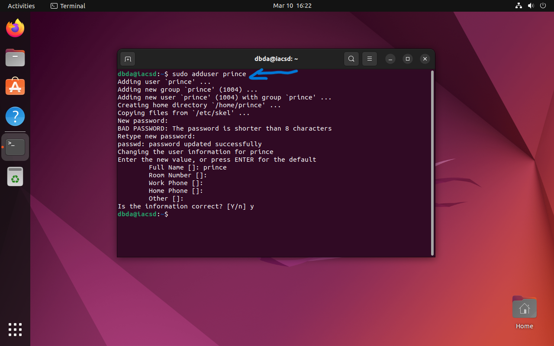

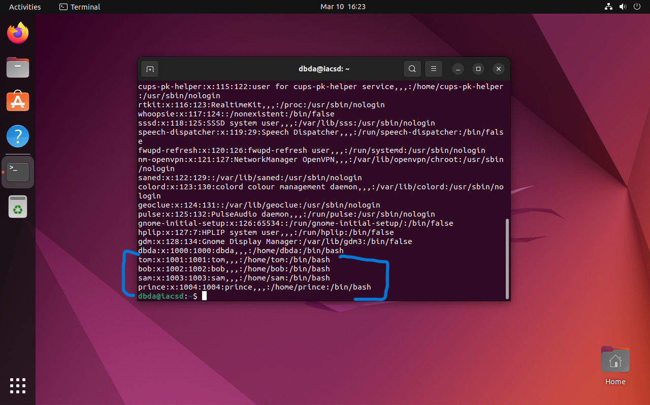

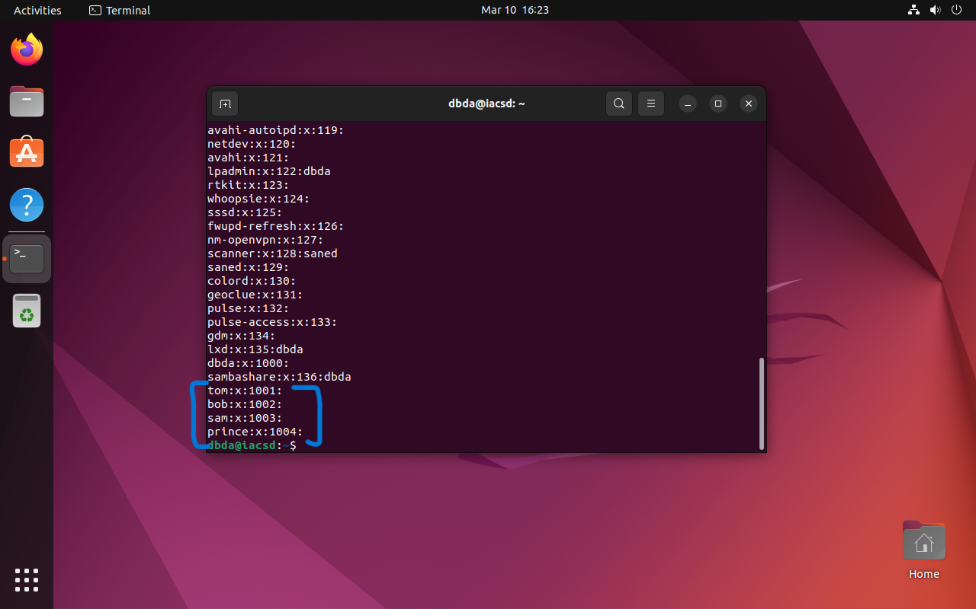

9. Create Group dac , dbda ,ditiss

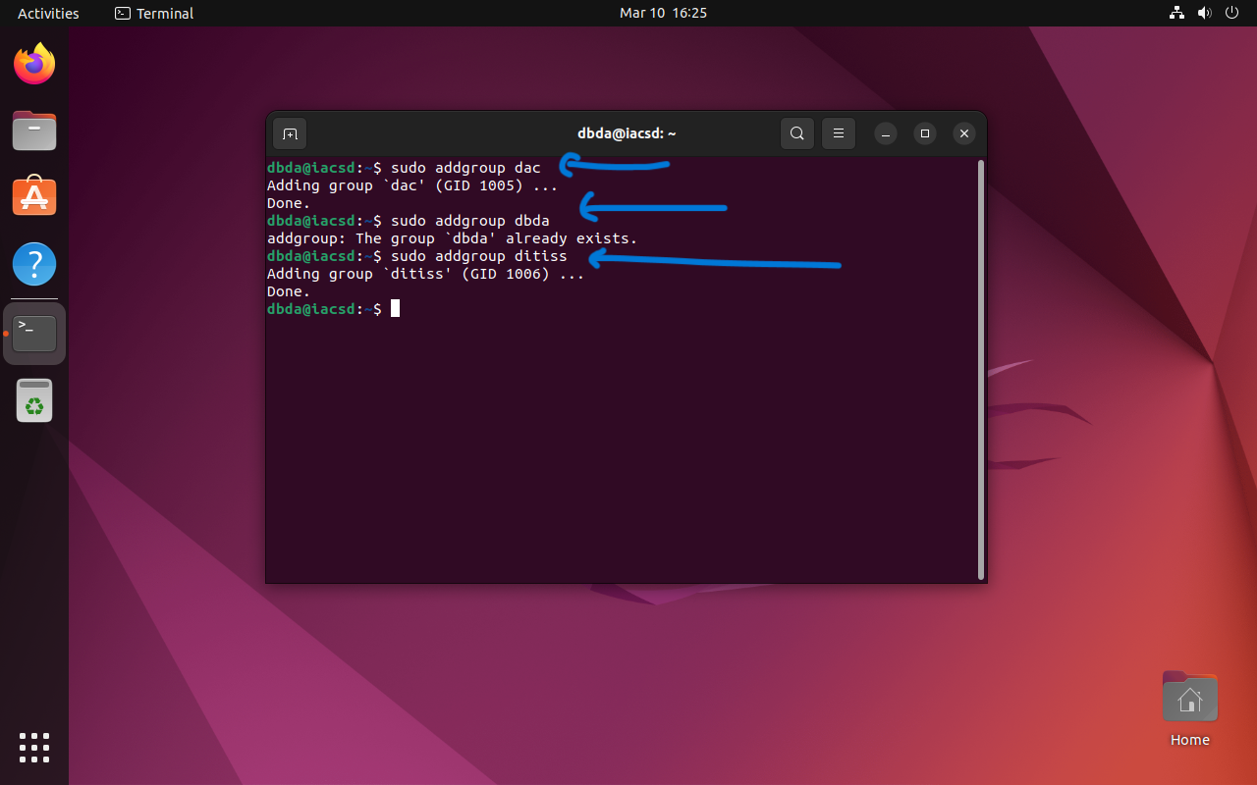

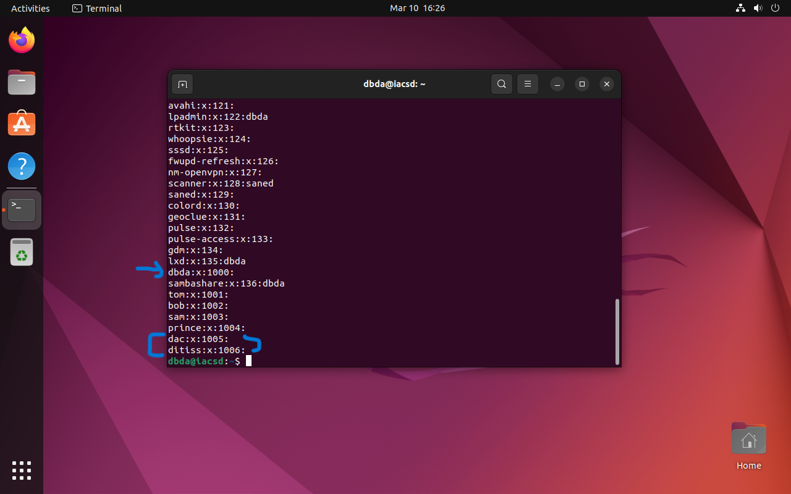

10. add user

Tom in dac

Bob in dbda

Sam in ditiss

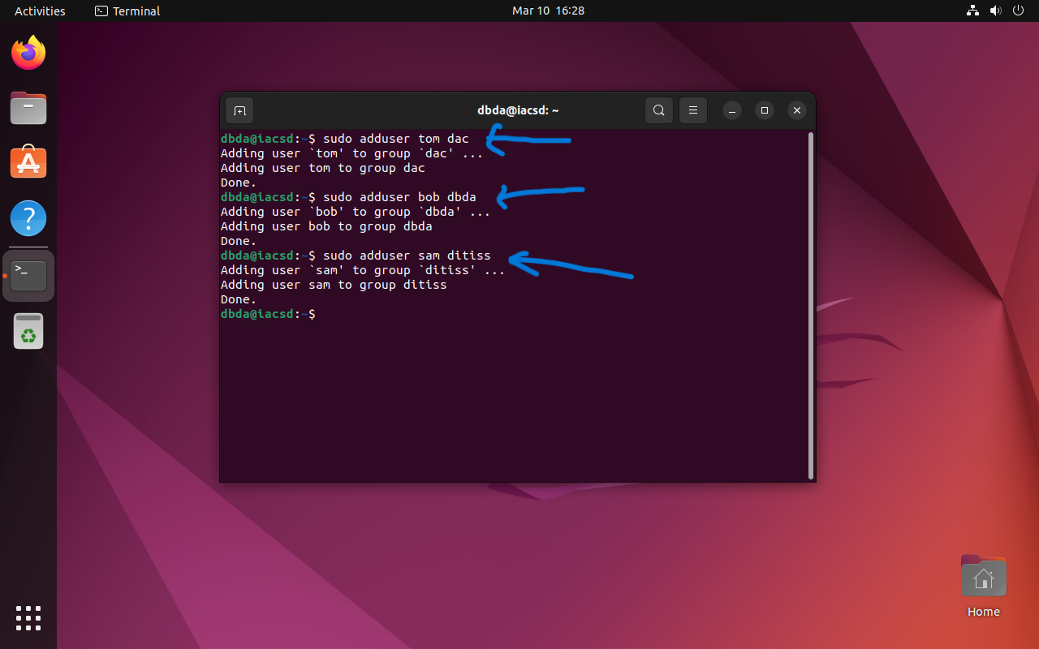



11. Login as prince and create iacsd directory in /tmp and create 4 files in iacsd with name project-1 project-2 upto 4

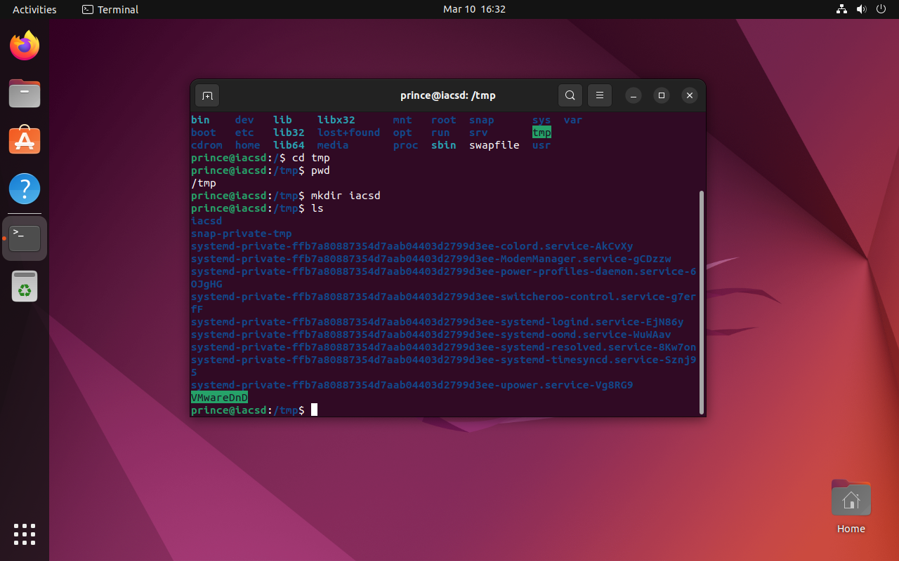

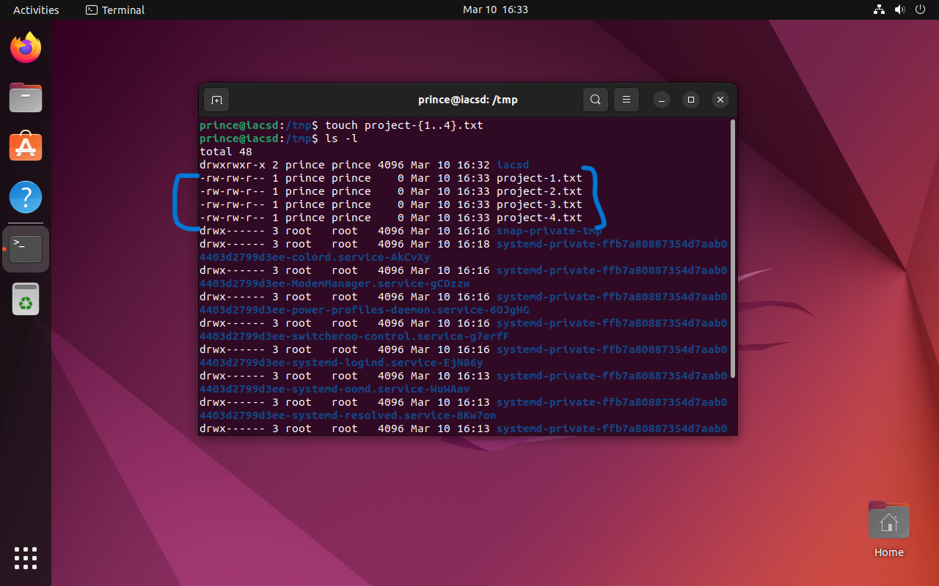

12. assign permissions to project files as below

Project-1 – tom should be owner of this

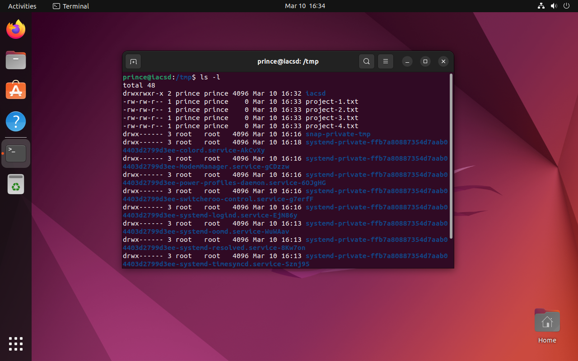

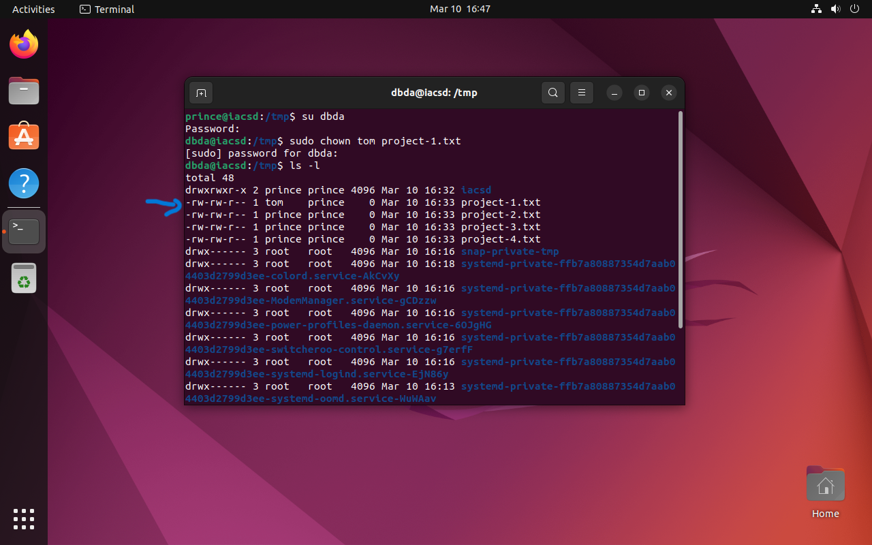

Project-2 – dac should be owner of this

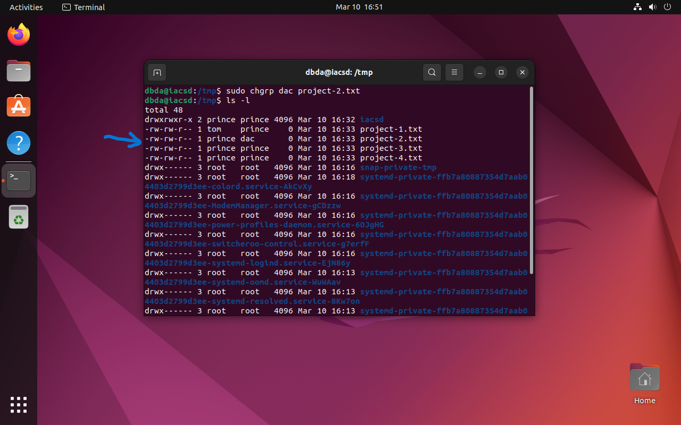

Project-3 --- others should not have any permission but tom should have rw access

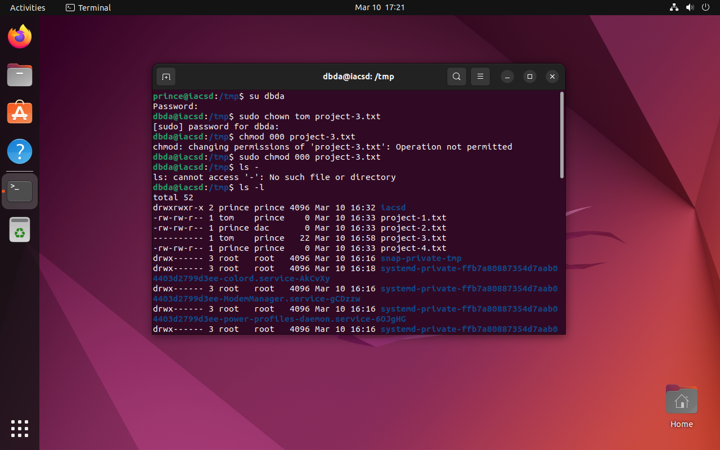

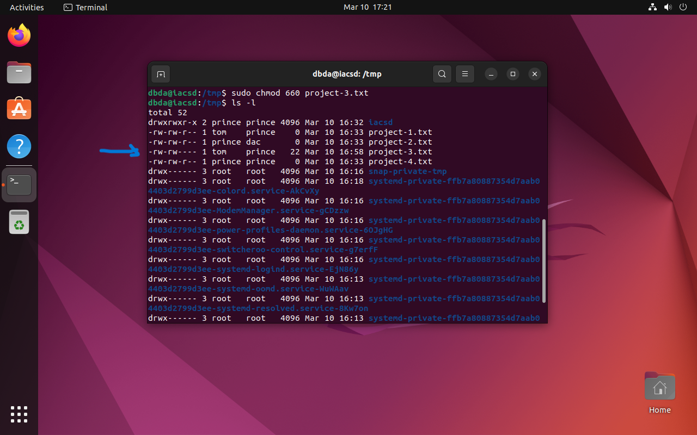

Project-4 – dbda group should have rwx permissions.

